**ON-demand Traffic light control**

Content

1. System description
2. System design
3. System flow chart
4. System epics for each module
5. System Layers
6. Solution Explorer
7. Application FUNCTIONS

**system description:**

traffic light system equipped with 6 led and one push button the first 3 led is for normal mode which dedicated for car movement and the second 3 led dedicated for pedestrian movement

**System design:**

- The system is designed to run in one of two modes, Normal mode & Pedestrian mode.  
- The system consists of 6 LEDs and one push button.  
- It runs all the time in the normal mode unless the button is pressed, then it runs in the pedestrian mode.  
- In normal mode Cars' LEDs will be changed every five seconds starting from Green then yellow then red then yellow then Green, The Yellow LED will blink for five seconds before moving to Green or Red LEDs   
- If entered pedestrian mode while car green led is on then the car green led , walker red led AND the yellow LED will be on for 5 secs then the car red and the pedestrian LED turns on.

- If entered pedestrian mode while car red led is on the yellow LED start blinking for 5 secs then the car red and the pedestrian LED turns on.

**system flow chart**

**System epics for each module**

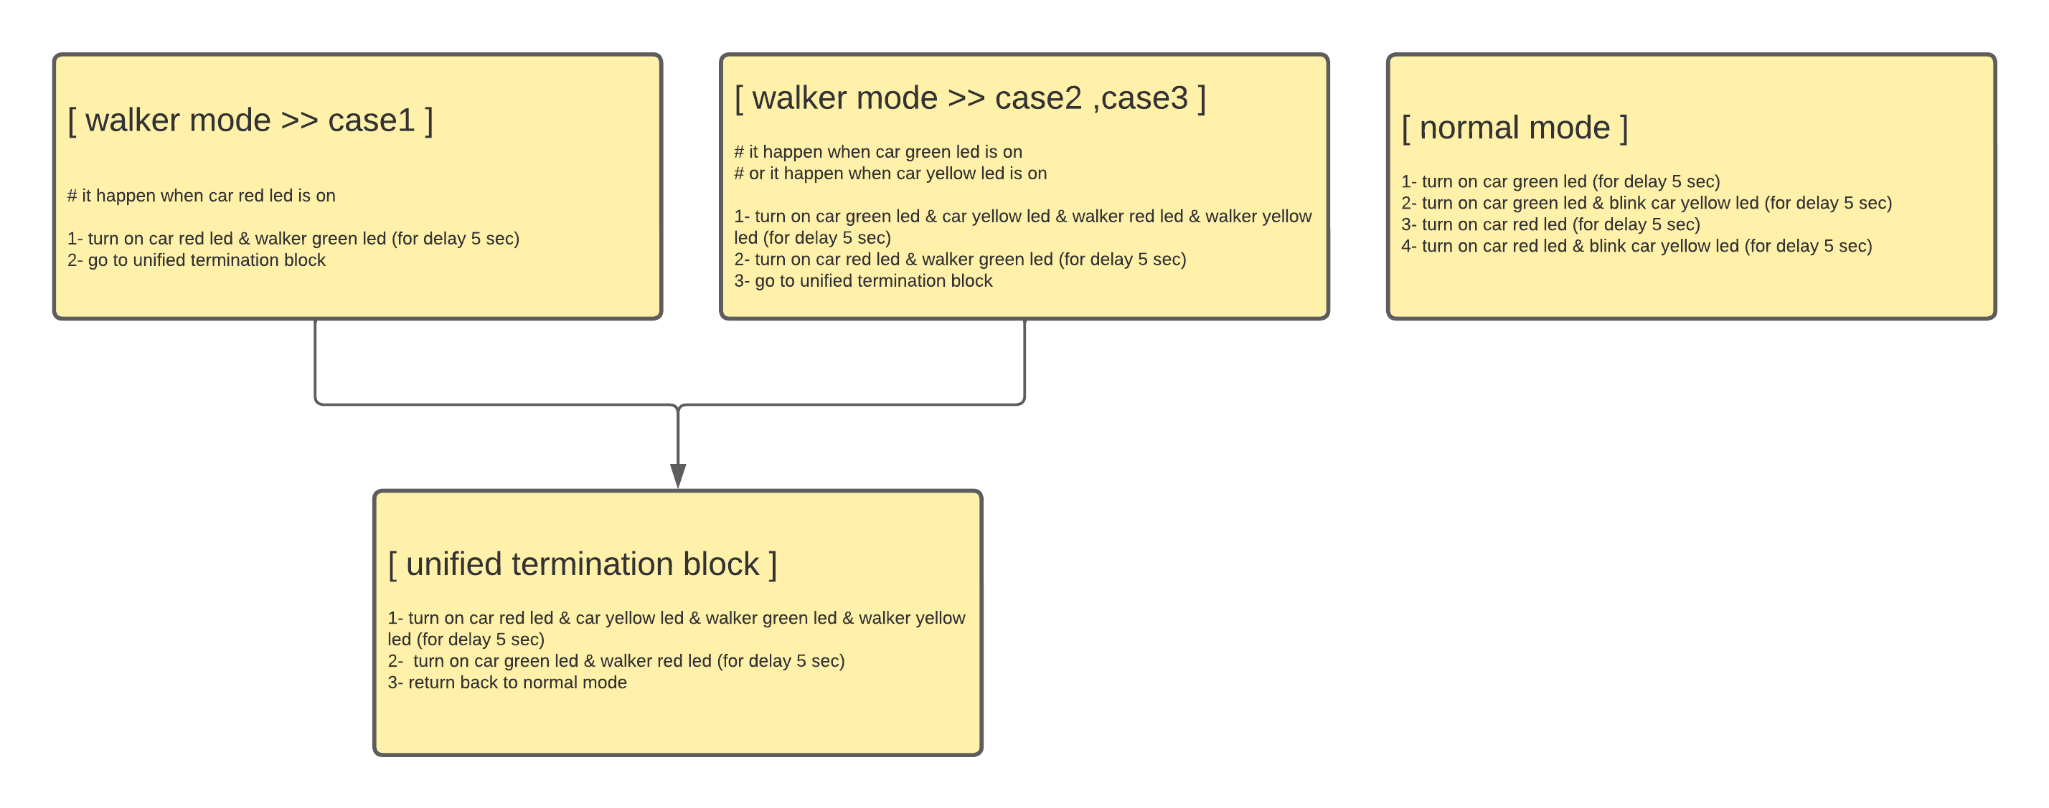

**System Layers:**

• APP  
• HAL  
• MCAL

**Solution Explorer:**

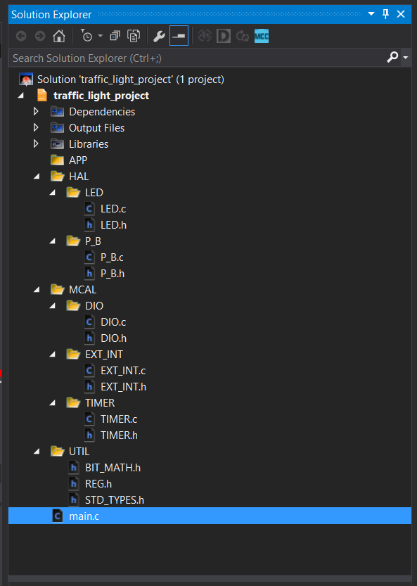

**Application FUNCTIONS**

1. delayINmilliSec(u32 TIME)
2. LED_ON(u8 LED_PORT, u8 LED_PIN);
3. LED_OFF(u8 LED_PORT, u8 LED_PIN);